**Landing, Login, and Enrollment Pages Development**

Rebecca Yorty

The University of Arizona Global Campus

CST499: Capstone for Computer Software Technology

Dr. Amjad Alkilani

May 9th, 2022

Server side scripting, such as PHP, in combination with HTML, can create a client facing web-based application where users can enter data that is saved, stored and retrieved from a server. Or users can do searches on specific datasets that are stored on the server.

**Explain how to run a PHP file in XAMPP**

PHP is a server-side language that can be embedded into the HTML code. PHP can return a string or perform an action. To run a PHP file, you must first have XAMPP installed on your machine and then have <html> as the first line in the PHP file. Next type localhost/*phpfilename*.php in the address bar and that PHP file should open and display your HTML page.

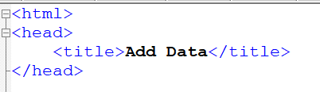

****Display of page:

**Create the landing page, login page, and registration page for new users.**

*Screenshot of the Student portal website:*



*Screenshot of the login page layout:*

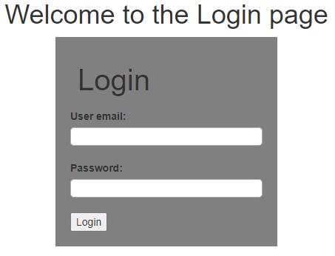

*Screenshot of the ‘User registration’ page:*

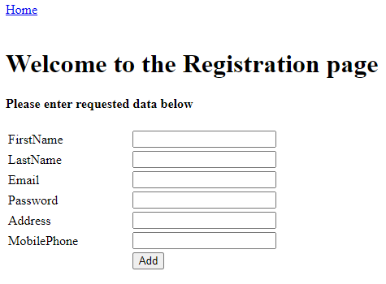

**Create the MySQL database and tables**

Script to create the SQL database:

CREATE DATABASE `test`;

Script to create the table in the ‘test’ SQL database:

use `testdb`;

CREATE TABLE `regis` (

`first_name` varchar(100) NOT NULL,

`last_name` varchar(100) NOT NULL,

`email` varchar(100) NOT NULL,

`password` varchar(100) NOT NULL,

`address` varchar(100) NOT NULL,

`m_phone` varchar(100) NOT NULL,

PRIMARY KEY (`ssn`)

);

**Discuss the MySQL database functions that you used and the steps you took to create the database connection custom class**

I first created a schema and then created a table

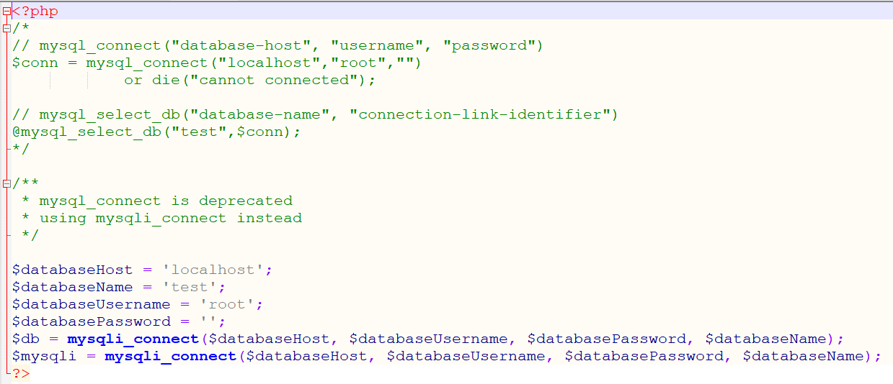

**Develop the registration page layout**

<html>

<head>

<title>Add Data</title>

</head>

<body>

<a href="index.php">Home</a>

<br/><br/>

<h1> Welcome to the Registration page</h1>

<h4> Please enter requested data below</h4>

<form action="registration.php" method="post" name="form1">

<table width="25%" border="0">

<tr>

<td>FirstName</td>

<td><input type="text" name="first_name"></td>

</tr>

<tr>

<td>LastName</td>

<td><input type="text" name="last_name"></td>

</tr>

<tr>

<td>Email</td>

<td><input type="text" name="email"></td>

</tr>

<tr>

<td>Password</td>

<td><input type="text" name="password"></td>

</tr>

<tr>

<td>Address</td>

<td><input type="text" name="address"></td>

</tr>

<tr>

<td>MobilePhone</td>

<td><input type="text" name="m_phone"></td>

</tr>

<tr>

<td></td>

<td><input type="submit" name="Submit" value="Add"></td>

</tr>

</table>

</form>

</body>

</html>

**Develop the registration page PHP source code**

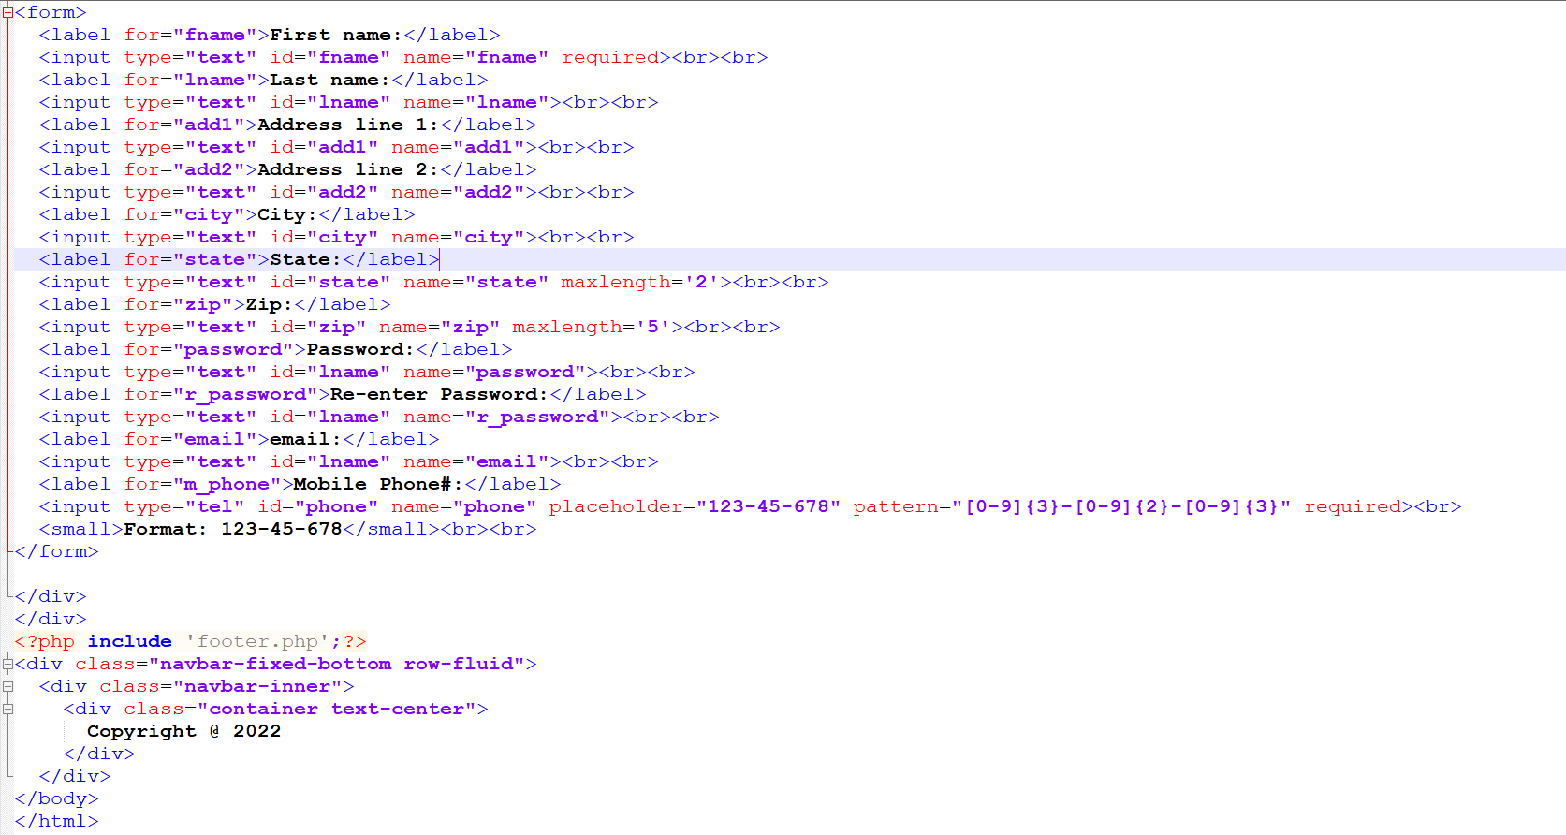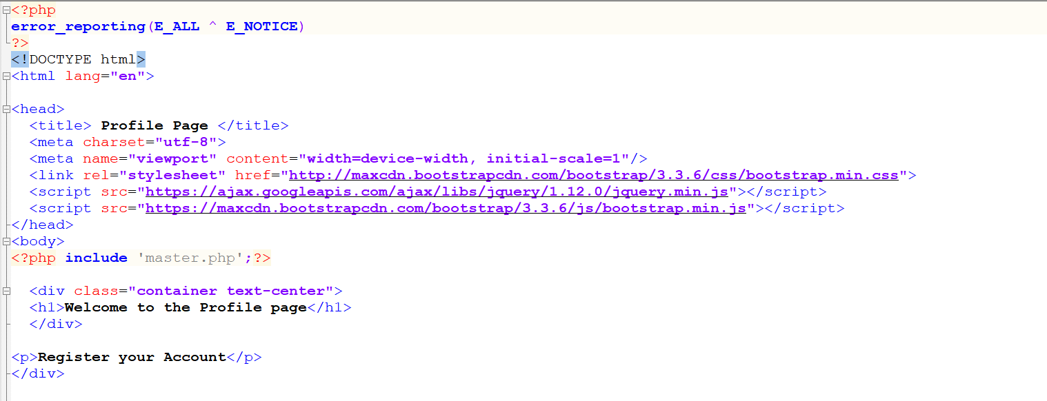

**Develop the table that saves the user information in the database**

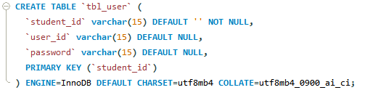

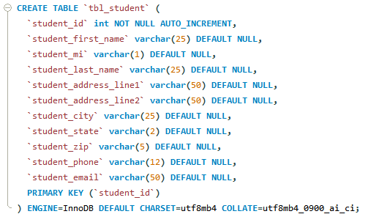

**Explain the steps taken to create the registration page and save the user information in the database**

I typed the code into Notepad++ and then saved it as a .php file in my ‘htdocs’ folder. I then Googled how to add fields to enter data into an HTML document and navigated to W3Schools. Reading through the W3Schools material. I was able to add the labels and the input boxes. W3Schools has a ‘Try it Yourself’ feature which allows a user to type in code and run it to test it out. After adding all of the required fields, plus some additional fields, I then saved the file. I tested the aesthetics by typing ‘localhost/registration.php’ into my browser. I also retested my master page, and ensured that when I can click on the ‘Registration’ link, the ‘Welcome to the registration page’ is displayed along with all of the fields that I added for new user registration.

To save user input into the database, I have to create a user data php page to temporarily store the user input until it is submitted and written to the SQL database.

In conclusion, using a combination of applications and languages almost anyone can create a client facing web-based application where the owner has control over the layout and the content on the pages and control over how the data is stored, retrieved and used.

**References**

Tsui, F., Karam, O., & Bernal, B. (2018). [Essentials of software engineering](https://ashford.instructure.com/courses/100130/modules/items/5077278)(4th ed.). Jones & Bartlett Learning.